# TASK 1: BPMN DIAGRAM

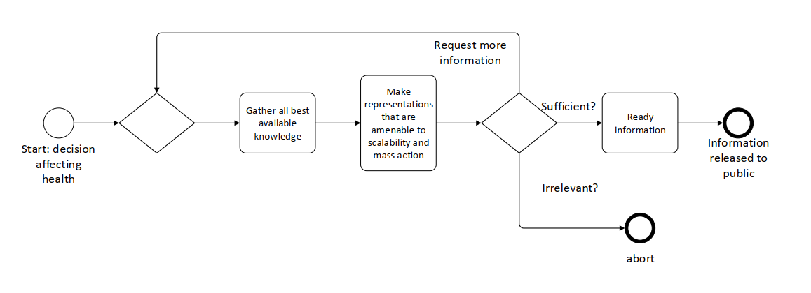

The specific aspect of the manifesto being focused on is making computable biomedical knowledge easily findable.